The effect of chitosan on regeneration of lily (Lilium longiflorum ‘Ester Lily’) from bulb scale explants cultured in vitro

Kantamaht Kanchanapoom¹, Pattaraporn Pimolthai¹, Kamnoon Kanchanapoom^{2*}

¹Center for Genomics and Bioinformatics Research, ² Department of Biology, Faculty of Science, Prince of Songkla University, Hat Yai, Songkhla, 90112, Thailand;

*Corresponding author e-mail: kamnoon.k@psu.ac.th
Tel: 66 089 7383600; Fax 66 074 288501

Abstract
Bulb scales of Lilium longiflorum ‘Ester Lily’ were cultured in vitro on Murashige and Skoog (MS) medium containing several concentrations of chitosan or BA. High frequency regeneration of shoots was obtained on MS medium supplemented with 25 mg l⁻¹ chitosan or 5 mg/L BA with 5.0 shoots and 4.7 shoots, respectively. When individual shoots were transferred to MS medium containing 1 mg l⁻¹ IBA complete plantlets were obtained. Acclimatization and survival in field conditions of the regenerated plants was 100%.

Key words: Easter Lily, micropropagation, multiple shoots, plant regeneration, shoot
organogenesis

Running title: Effect of chitosan on growth of lily.

INTRODUCTION
The genus Lilium, a monocot belonging to the family Liliaceae is one of the most important bulbous crops (van Aartrijk et al. 1990). Lilium longiflorum Thunb., commonly known as Easter Lily has large and attractive flowers. Therefore it is used worldwide in the flower industry as a cut flower and as potted plant mainly due to their large flowers and attractive flowers (Priyadarshi and Sen 1992). Lilies are typically propagated from bulb scaling. However, this is an inefficient propagation method for commercial purposes since the planting material has a very low multiplication rate and thus restricts large-scale cultivation of this plant. Plant tissue culture methods are currently applied to many plant species as a tool to obtain a large number of elite plants. Therefore, in vitro micropropagation is essential for rapid propagation of lily plantlets. Plant regeneration has been achieved from a vast array of lily explants including bulb scales (Stimart and Ascher 1978; Kumar et al. 2005), leaves (Niimi 1995), pedicel (Liu 1986), flower organs (Horita et al. 2002), anthers (Han et al. 1997) and callus (Tribulato et al. 1997).
The success of plant tissue culture depends mainly on the development of suitable culture medium. In general, BA is the most effective cytokinin for in vitro shoot induction. In recent years chitosan has attracted notable interest due to its biological activities such as antimicrobial and antitumor. Chitosan is widely recognized as stimulant of plant growth. It was shown that chitosan enhanced plant growth and induced early flowering in developing flower buds of Eustoma grandiflorum (Ohta et al. 1999). The growth of protocorm-like bodies in Dendrobium phalaenopsis orchid plants was accelerated in the presence of chitosan in VW liquid medium (Nge et al. 2006). Chitosan is a natural carbohydrate polymer and the deacetylated form of chitin that is present in shells of crustaceans, in cuticles of insects and in the cell wall of fungi and some algae (Nge et al. 2006). Therefore, this communication aims to find the effect of chitosan as a growth stimulator on the regeneration of L. longiflorum ‘Ester Lily’ via organogenesis.

MATERIALS AND METHODS
Plant materials
The bulb scales of L. longiflorum ‘Ester Lily’ bulblets were collected from field-grown plants in Chiang Mai Province, northern Thailand and washed thoroughly by running tap water. The bulb scales were surface sterilized with 70% ethanol for 1 min, followed by immersion for 20 min in a sterilization solution of 20% (v/v) Clorox™ (5.25% NaOCl) containing 1-2 drops of Tween-20 emulsifier per 100 ml solution followed by 10% (v/v) Clorox™ for 10 min. After the surface sterilization, these explants were rinsed three times with sterile distilled water. Following disinfection, the whole part of each bulb scale explants were excised transversely into 3 segments each with 1 cm long (Fig. 1a) prior to transferring to MS (Murashige and Skoog 1962) basal medium for further study.

Micropropagation
After 2 weeks of initial culture on MS basal medium, the bulb scales were transferred to MS medium with plant growth regulators for shoot proliferation. In the first experiment, chitosan at the concentrations of 0, 5, 10, 15, 20, or 25 mg l⁻¹, and BA at the concentrations of 0, 1, 3, or 5 mg l⁻¹ were used. In the second experiment, the effects of chitosan were examined at the concentrations of 0, 5, 10, 15, 20, or 25 mg l⁻¹ in the presence of 5 mg l⁻¹ BA. The explants were subcultured to fresh medium at 4-week-interval for 2 times. After this period excised single shoots from multiple shoots were transferred to a fresh medium for root induction.
In vitro culture conditions
All culture media consisted of MS salts and vitamins supplemented with 3% sucrose and 0.82 % Mermaid agar. The pH of media was adjusted to 5.8 with 1 N NaOH or 1 N HCl prior to autoclaving at 1.05 kPa, 121˚C for 20 min. Cultures were maintained at 25±1˚C air temperatures in a culture room with a 16-h light photoperiod under 20 μmolm⁻² s⁻¹ photosynthetic photon flux intensity provided by cool white fluorescent lamp. Plant material was cultured in glass-capped culture jars (115 ml capacity) each containing 20 ml of the medium.

Root induction and plant acclimatization
Regenerated shoots were transferred to MS medium containing 1 mg l⁻¹ IBA for rooting. Well rooted plantlets were transferred to plastic pots containing sterilized vermiculite for 1-2 weeks before being transferred to the glasshouse.

Statistical analysis
One explant was implanted per culture jar with 20 replicates per treatment. Each experiment was conducted on two different days. The percentage of shoot regeneration was monitored as growth parameter. The numbers of regenerated shoots was examined by analysis of variance followed by Duncan’s multiple range test at P≤0.05 using SPSS® (Release 11.5, SPSS, Chicago, IL, USA)

RESULTS
After 2 weeks of culture on MS basal medium, each basal part of bulb scales swelled and began to change from a yellowish to a green color and subsequent differentiated shoots (Fig. 1b). Table 1 shows the number of shoot formation from bulb scales in L. longiflorum ‘Ester Lily’. The number of shoots was enhanced on the media supplemented with chitosan and BA in comparison with control thus resulting in morphogenetic responses in terms of shoot formation. The average number of regenerated shoots was approximately 5.0 and 4.7 (P≤0.05) on MS medium containing 25 mg l⁻¹ chitosan or 5 mg l⁻¹ BA, respectively. The feature of shoots developed on MS medium containing chitosan had lots of small and dark green leaves (Fig. 1b) and an increase in chitosan levels progressively increased shoot number. On BA containing medium, cultures produced the same trend as compared to chitosan while at the highest level of BA tested, shoots number decreased. However, there was no significant difference in the shoot number; hence an experiment was subsequently conducted to determine the optimal concentrations of chitosan (0, 5, 10, 15, 20, or 25 mg l⁻¹) with BA held constant at 5 mg l⁻¹. Results revealed that the number of shoots decreased with the increase of chitosan concentration, and 10 mg l⁻¹ chitosan yielded the highest number of 3.3 shoots (P≤0.05, Table 2). Combinations of chitosan and BA were less effective in promoting shoot multiplication when compared to chitosan or BA alone. The multiple shoots with green leaves obtained from MS medium supplemented with 25 mg l⁻¹ chitosan continue to proliferate after successive subcultures with an average of 5 shoots per cycle. Clonal propagation of shoots was achieved by repeating subculture at 4 week intervals. Each regenerated shoot provided 125 shoots in 12 weeks, for a total production of 500 shoots in 12 months. At all concentrations of chitosan and BA tested, direct organogenesis (no callus stage) occurred.
The induction of roots is an important step to form complete plantlets. To establish a rooting protocol, regenerated shoots were excised and transferred to rooting medium. Root formation occurred on MS medium devoid of plant growth regulator or supplemented with 1 mg l⁻¹ IBA, after 3 weeks of culture. However, MS medium supplemented with IBA was more effective in terms of initiation of roots per shoot. With 1 mg l⁻¹ IBA incorporated in the medium, thick, long and fibrous roots developed from the basal end of the shoots (Fig.1c). Three weeks of rooting incubation was adequate before transplanting to polystyrene pots containing soil mixture (1 sand: 1 manure: 1 decayed leaves). In vitro-derived plants did not show any phenotypic variation during subsequent vegetative development even after 2 years of cultivation when compared to the original plants (Fig.1d).

DISCUSSION
It has been demonstrated that bulb scales of lily have a high regeneration potential hence they are most commonly used as explants for vegetative propagation (Niimi 1995). Chitosan is a natural carbohydrate polymer derived by deacetylation of chitin which consists of N-acetyl-D-glucosamine and D-glucosamine residues linked by β-1, 4 glycosidic bonds and it has been shown to affect plant growth (Chibu and Shibayama 2001). To stimulate efficient micropropagation in plant tissue culture, chitosan has been added to the culture medium in a number of species such as Dendrobium phalaenopsis (Nge et al. 2006) and Elaeis guineensis (Kanchanapoom et al. 2010).
In this study, a protocol for shoot regeneration from bulb scales in L. longiflorum ‘Ester Lily’ has been developed. The shoots occurred directly via organogenesis and without forming callus on MS medium containing chitosan and BA. Chitosan and BA showed individual effects and the results indicated that differences in regeneration response were found on organ formation. A combination of chitosan and BA did not evoke a better response in shoot multiplication than BA or chitosan alone and this is probably due to the difference in endogenous levels of growth regulators or to a difference in sensitivity (Trewawas and Cleland 1983). Some other researches obtained results for other Lilium species with the combination of BA and IAA (Han et al. 2004; Han et al. 2005), TDZ and NAA (Xu et al. 2009). The interesting property of chitosan suggests its potential as a growth regulator for the micropropagation of lily. Regenerated shoots were rooted when transferred to MS medium containing no growth regulator. Obviously, the finding that rooting could be obtained readily implies that the culture medium was beneficial hence providing rapid clonal propagation. However, the improvement of rooting was found on MS medium supplemented with 1 mg l⁻¹ IBA. A similar trend was observed in root formation of Lanzhou lily (Lilium davidii var. unicolor) when transferred regenerated shoots to MS medium supplemented with 0.1-0.5 mg l⁻¹ IBA (Xu et al. 2009). After rooting, the rooted plantlets were potted in vermiculite for 1-2 weeks and successfully acclimatized to greenhouse conditions with a survival rate of 95% within 2-3 months.

Acknowledgements

This research was financially supported by the Faculty of Science, Prince of Songkla University, Hat Yai Campus, Songkhla, 90112, Thailand.

REFERENCES
van Aartrijk J., Blom-Barnhoorn G. J., van der Linde P. C. G. (1990). Lilies In: Ammirato P. V., Evans D. A., Sharp W. R., Yaspal P., Bajaj S. (Eds). Handbook of Plant Cell Culture. Vol 5 Ornamental Species: 535-576.

Chibu H., Shibayama H. (2001). Effects of chitosan applications on the growth of several crops. In: Uragami T., Kurita K., Fukamizo T. (Eds.). Chitin and Chitosan in Life Science, Yamaguchi: 235-239.
Han B. H., Yu H. J., Yae B. W., Peak K. Y. (2004). In vitro micropropagation of Lilium longiflorum ‘Georgia’ by shoot formation as influenced by addition of liquid medium Scientia Horticulturae, 103: 39-49.
Han B. H., Yae B. W., Yu H. J., Peak K. Y. (2005). Improvement of in vitro micropropagation of Lilium oriental hybrid ‘Casablanca’ by the formation of shoots with abnormally swollen basal plates. Scientia Horticulturae, 103: 351-359.
Han D. S , Niimi Y., Nakano M. (1997). Regeneration of haploid plants from anther cultures of the Asiatic hybrid lily ‘Connecticut King’. Plant Cell Tissue and Organ Culture, 47: 153-158.
Horita M., Morohashi H., Komai F. (2002). Regeneration of flowering plants from difficile lily protoplasts by means of a nurse culture. Planta, 215: 880-884.
Kanchanapoom K., Phongdara A., Kanchanapoom K. (2010). The effect of chitosan on the organogenesis of oil palm embryo-derived callus. Notulae Botanicae Horti Agrobotanici Cluj-Napoca, 38(1): 213-217.
Kumar S., Kashyap M., Sharma D. R. (2005). In vitro regeneration and bulblet growth from lily bulbscale explants as affected by retardants, sucrose and irradiance. Biologia Plantarum, 49: 629-632.
Liu L., Burger D. W. (1986). In vitro propagation of Easter Lily from pedicels. HortScience, 21: 1437-1438.
Murashinge T., Skoog F. (1962). A revised medium for rapid growth and bioassays with tobacco tissue culture. Physiologia Plantarum, 15: 473-497.
Nge K. L., Nitar N., Chandrachang S., Stevens W. F. (2006). Chitosan as a growth stimulator in orchid tissue culture. Plant Sciences, 170: 1185-1190.
Niimi Y. (1995). In vitro propagation and post-in-vitro establishment of bulblets of Lilium
japonicum Thunb. Journal of Japan Society for Horticultural Sciences, 63(4): 843-852.
Ohta K., Taniguchi A., Konishi N., Hosoki T. (1999). Chitosan treatment affects plant growth and flower quality in Eustoma grandiflorum. HortScience, 34(2): 233-234.
Priyadarshi S., Sen S. (1992). A revised scheme for mass propagation of Easter Lily. Plant Cell Tissue and Organ Culture, 30: 193-197.
Stimart D. P., Ascher P. D. (1978). Tissue culture of bulb scale sections for asexual propagation of Lilium longiflorum Thunb. Journal of American Society for Horticultural Sciences, 103: 182-184.
Trewavas A. J., Cleland R. E. (1983). Is plant development regulated by changes in concentration of growth substances or by changes in the sensitivity? Trends in Biochemical Science, 8: 354-357.
Tribulato A., Remotti P. C., Löffler H. J. M., van Tuyl J. M. (1997). Somatic embryogenesis and plant regeneration in Lilium longiflorum Thunb. Plant Cell Reports, 17: 113-118.
Xu L. F., Ma F. W., Liang D. (2009). Plant regeneration from in vitro cultured leaves of Lanzhou lily (Lilium davidii var. unicolor) Scientia Horticulturae, 119: 458-461.
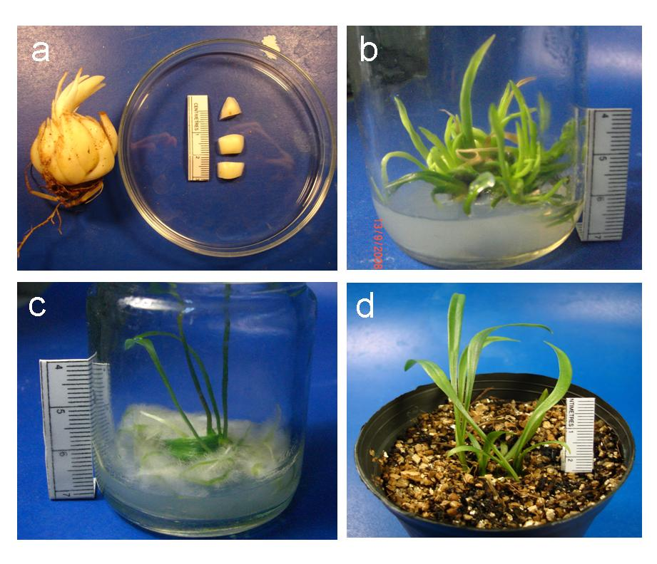
Fig. 1 Micropropagation of Lilium longiflorum ‘Ester Lily’. (a) Bulb
and transverse sections of bulb scales. (b) Clumps of adventitious
shoots developed on MS medium containing 25 mg l⁻¹ chitosan.
(c) Root induction on MS medium supplemented with 1 mg l⁻¹ IBA.
(d) Complete plantlets in soil.

Table 1 Effect of chitosan and BA on shoot multiplication in Lilium
longiflorum ‘Ester Lily’ bulb scale explants cultured on MS medium.
Chitosan  (mg l⁻¹) | BA  (mg l⁻¹) | Shoot induction  (%) | No. of shoots  (Mean ± SE)
0 | 0 | 100 | 1.7±0.36c
0 | 1 | 100 | 1.7±0.56c
0 | 3 | 100 | 4.4±0.83ab
0 | 5 | 100 | 4.7±0.93a
5 | 0 | 100 | 3.1±0.66abc
10 | 0 | 100 | 2.3±0.83bc
15 | 0 | 100 | 4.1±0.56ab
20 | 0 | 100 | 3.8±0.80abc
25 | 0 | 100 | 5.0±0.69a

The different letters within column show significant difference
analyzed by Duncan’s multiple range test at P≤0.05.

Table 2 Effect of different chitosan concentrations with 5 mg l⁻¹ BA on shoot
formation in Lilium longiflorum ‘Ester Lily’ cultured on MS medium.

Chitosan  (mg l⁻¹) | BA  (mg l⁻¹) | Shoot induction  (%) | No. of shoots  (Mean ± SE)
5 | 5 | 100 | 1.0±0.4cd
10 | 5 | 100 | 3.3±0.2a
15 | 5 | 100 | 2.0±0.1b
20 | 5 | 100 | 1.0±0.5cd
25 | 5 | 100 | 0.8±0.2cd

The different letters within column show significant difference
analyzed by Duncan’s multiple range test at P≤0.05.

